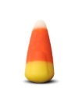
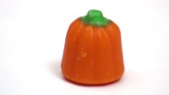
Candy Corns Candy Pumpkins

_________ + __________ = __________
- The total pieces of candy in my bag is ___________.
- The number of candy corns is/is not equal to the number of candy pumpkins.
- There are ________ more __________ than _________.
- There are ____________ candy corns, so there must be ___________ candy pumpkins because ____________ --- ____________ = ____________.
- If Mrs. Buckner only likes candy corn and Mrs. Hoffman only likes candy pumpkins, how can we group the candies together to share them?
How many more do we need to add to a group, so that both teachers can have the same amount of candy? What will our new total be?
Mrs. Buckner
Mrs. Hoffman
Total

- How might you group the candies if Mrs. Buckner and Mrs. Hoffman were going to share the candies evenly with you? Would there be any left over? Use the space below to show your grouping.

- Use the following words to identify similarities and differences between the candy corns and the candy pumpkins.
More Candy Mrs. Buckner Mrs. Hoffman
Less Sweet Orange Yellow Green

